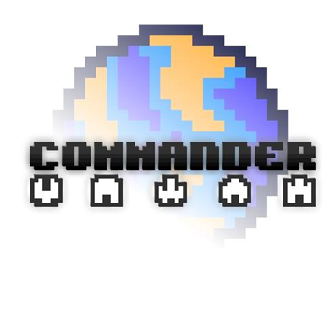

Game Design Document

Table of contents

1. Introduction 3

2. Story 4

3. Turrets 7

4. Power-ups and spaceships 9

5. Enemies 11

6. Level design and balance 12

7. Worlds 15

8. Game modes & leaderboards 17

9. Assets (Graphics & Audio) 19

10. Improvements 22

1. Introduction

*Commander* is an innovative tower defense I made in 2010. A preview version was released on Xbox Live Indie Games (XBLIG) marketplace and Windows in November. Since then, I addressed the issues reported by the community and reviewers by updating the Windows release. My goal is to release the final version of *Commander* this year on XBLIG and Windows.

This game design document contains *only* the features and improvements that will be added in the final version of *Commander*, based on the current version. 2 months of work are estimated to complete all the tasks listed at the end of each section.

1. Story

*Commander* has a simple storyline: In the future, a war rages between humans and aliens. The evil aliens throw asteroids at humans to destroy their colonies. As the *Commander* (and under the orders of an enigmatic man in black, the *Commodore*), you protect the colonies by installing turrets and by driving crazy spaceships. Unfortunately, you inevitably fail to protect them as a too-powerful alien mothership comes and wipes the colony at the end of each level.

The main story will be told as the player progress from one world to another. This main story is as follow:

* In the first world, human colonies establish contact with aliens. They turn out to be hostiles and destroy almost all the human colonies;
* In the second world, the aliens progressed to the solar system and a battle rages in the Earth’s thermosphere between human and aliens’ spaceships. The aliens win this battle;
* In the third world, the aliens are now attacking the Earth’s biggest cities a-la-Independence Day and they again succeed;
* In the fourth world, the aliens, which are aware of the importance of the turrets in this war, set in motion an evil plan to hack them: they infest them with nanobots but those turrets deliver an outstanding resistance, win the battle and become stronger than ever;
* In the next three worlds, the aliens are fight off from the Earth, then from the Earth’s thermosphere and finally from the last remaining human colonies;
* In the last world, the humans fight off the aliens until they reach their homeworld and engage in a final epic battle. The humans win. The end.

Please see the *Worlds* section for more details.

# The story will be told by:

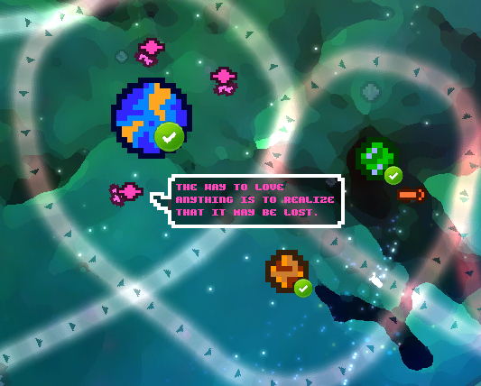

1. **Talking turrets in the world map**

The turrets will randomly display quotes that tell their story as a turret (small talk) and more important quotes about the war, the aliens, the *Commodore* and the mothership.

1. 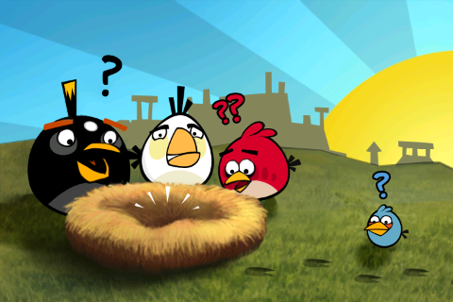**A mini cutscene between each world**

Between each world, a mini cutscene a-la-Angry-Birds will be shown. The cutscenes tell the story in a more linear way than the turrets. They will put an image on one or more quotes of the turrets. Note: The player must be able to skip the cutscenes.

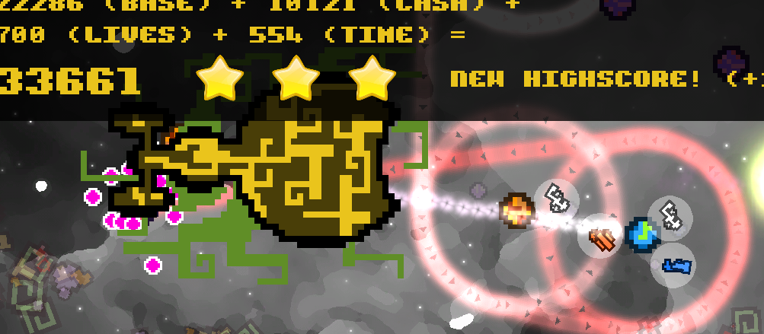

1. **An animation at the end of each level** (see *Worlds* sections)

At the end of each level, an animation will be played as described in the *Worlds* section. For example, the mothership will destroy the colony entirely in the World 1. This animation must be played before the data (total score, stars, etc.) is displayed or in a way that the mothership and the data can co-exist.

1. 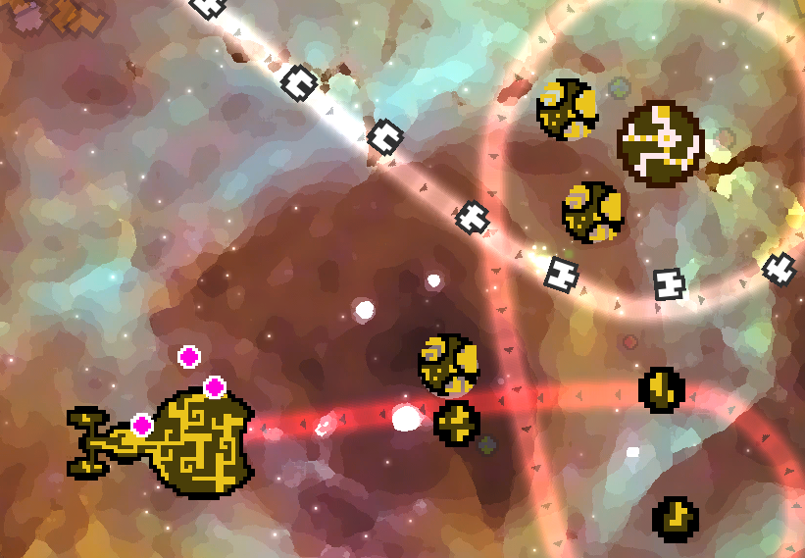**5 different environments with their own set of assets (backgrounds, planets, sounds, animations, etc.)** (*see Worlds section*)

For example, in the last world the player is in the alien homeworld playing the aliens trying to survive a human counter-attack. All the assets are changed to represent aliens’ turrets, backgrounds, etc.

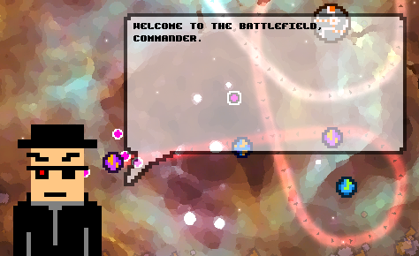

1. **Briefings by the *Commodore* at the start of a level**

At the beginning of some levels, the *Commodore* will unfold the story about himself, the war, the aliens and the mothership.

# To do:

* Produce *Commodore*, aliens, mothership, war and turrets stories;
* Produce turrets and *Commodore* quotes;
* Revisit the actual quotes system to display quotes more often and remove actual quotes placeholders;
* Create a new cutscene scene and all the transitions/controls necessary when going from a World to another one;
* Produce the cutscenes (9, including one intro and one outro);
* Produce the animations at the end of each level (8);
* Put in place the *Commodore* quotes at the beginning of some levels by using the actual tutorial system.
* See the *Worlds* section for more things to do.

1. Turrets

*Commander* has actually 6 turrets. These new turrets will be available in the final product:

1. **The booster**

* Description: This turret boosts other turrets stats that are in its range. Upgrading this turret increase its boost percentage and range.
* Why create this turret: This turret has the particularity to have an effect on other turrets rather than enemies. It’s a less costly alternative to upgrading individual turrets in a crowded spot.

1. **The gunner**

* Description: This turret has the highest fire rate of all. It’s a machine gun that focuses on one enemy at the time. The longer it focuses on an enemy, the less accurate it becomes. Visually, we won’t see the bullets but only the impacts on the enemies.
* Why create this turret: This turret is a boosted basic turret with the advantage to always hit the target in the first x seconds of use (between two cooldowns). It should be more costly to upgrade than the basic or laser turret.

1. **Mortar**

* Description: This turret’s range can be set up by the player (default: center of the screen). When this turret fires, we should see a bullet falling from the “sky” and hitting the “ground” seconds later.
* Why create this turret: This turret can be controlled by the player when he is waiting for income. This is the only turret with a detached fire range and controllable by the player.

1. **Nanobots**

* Description: This turret fires a nanobots cloud that attaches itself to enemies. These nanobots slowly degrade the enemies’ lives over time.
* Why create this turret: This turret is the only one to have an effect on an enemy after the enemy has left it fire range and should be useful when used in zones where there is a gap between two turret fire ranges.

1. Power-ups and spaceships

*Commander* has actually 4 power-ups. These new power-ups will be available in the final product:

* **Deadly shooting stars**

There are currently shooting stars in the background of the levels. The effect is purely visual but with this power-up (that you can only buy once), the shooting stars become deadly to enemies.

* **Pulse from the planet to protect**

This power-up is only available on the planet to protect. When bought, a deadly pulse is sent on the path and strikes every enemy.

* **Nodes**

For a certain amount of time, nodes appear on the path to lengthen it.

* **Shield**

The planet to protect is temporary invincible. This power-up is useful when enemies are too close to the planet to protect.

* **Sniper**

For a certain amount of time, the player controls a sniper gun. Visually, there will be a magnifying glass on the battlefield with a reticle. The sniper will produce a sound when triggered and a recoil effect. When touched, an enemy die instantly, regardless of it lives amount.

* **Automatic collector**

An AI-controlled collector that frees the player from having to manually controls it.

* **Dark side**

The enemies are hit by a mysterious force when they go behind a planet (for now they can’t be hit when they go behind a planet).

1. Enemies

*Commander* has actually 6 enemies. These new enemies will be available in the final product:

1. **Swarm**

When hit, this enemy explodes in 3 smaller and slower enemies.

1. **Shadow**

Every x seconds, this enemy teleports itself +/- on its next move.

1. **Selector**

This enemy reflects basic bullets and missiles.

1. Level design and balance

*Commander* has 3 major issues concerning balance:

* The game is too hard (i.e. the rookie player will die too many times in the first levels);
* The first upgrade levels of the turrets are useless (i.e.: the player upgrade the turret as soon as he buy them);
* The missile turret combined with the slow motion turret is the best strategy in most levels (where they are available).

# Solutions:

1. **The game is too hard**

The preview of *Commander* had only 9 levels where every turrets / power-ups / enemies were available. In the final version, the availability of these components must be spawn over all the 50 levels, giving the player the time to learn the battlefield and his tools. As an example, the availability chart for the turrets should looks like:

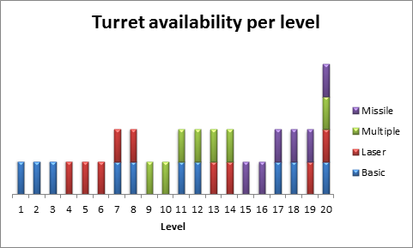

1. **The first upgrade levels of the turrets are useless**

A document (see example below) describing the different variables in play to determine each turret properties is available in the project. However, this document is incomplete: it doesn’t take into account the enemies and power-ups data. This document must be revised.

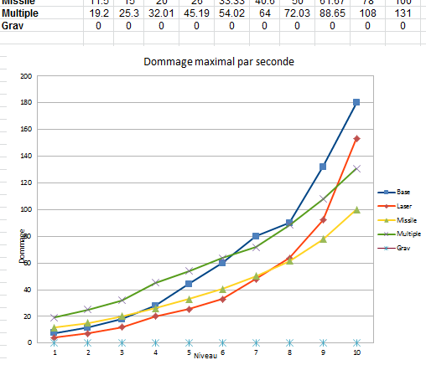

Figure 5 : The actual tweaking document (partial)

1. **The missile turret combined with the slow motion turret is the best strategy in most levels**

This problem is due to the fact that the slow motion turret pack enemies together and the missile has a certain explosion radius that touch many enemies at once. The solutions are:

* Reduce the missile damage;
* Reduce the missile explosion radius;
* Create fewer levels that permit this combination.

# To do:

* Create a document that describes each level in terms of weapons, enemies and resources availability;
* Revise the document describing the weapons and enemies properties to create a perfect balance;
* Implement and playtest these changes.
* Note: this should be done after integrating the new weapons and enemies, and generating the levels layouts with the level editor.

1. Worlds

*Commander* has actually 1 preview world with 9 levels. The goal is to have 50 levels spread over 8 worlds (a-la-Mario Bros). The game will be set in 5 different environments with their unique set of assets:

Table 1 : The game's environments

|  |  |  |  |  |  |
| --- | --- | --- | --- | --- | --- |
|  | Human colonies | Earth’s thermosphere | Earth’s cities1 | Inside of a turret | Aliens homeworld |
| The player must protect… | The colony’s main planet. | The humans’ battlecruiser. | An Earth’s city. | The turret’s motherboard. | The alien’s mothership. |
| Enemies are… | Asteroids. | Alien spaceships. | Alien troops. | Alien nanobots. | Human spaceships. |
| Turrets are placed around… | Planets. | Humans’ big spaceships. | Human buildings. | Turret’s microchips. | Alien’s planets. |
| Turrets are… | Humans. | Humans. | Humans. | Humans. | Aliens. |
| Backgrounds depict… | Space. | The Earth, viewed from space. | The Earth’s biggest cities, viewed from the sky. | The inside of a turret which is like a living organism. | Alien’s homeworld which is like hell. |
| When the level is won… | The alien mothership wipe the colony (loosing) / The human battlecruiser destroy the aliens on the asteroid belt (winning). | The aliens’ spaceships wipe the humans’ battlecruiser (loosing) / The human’s battlecruiser destroy the aliens’ spaceships on the asteroid belt (winning). | The alien’s biggest spaceships destroy the city to protect a-la-Independence Day (loosing) / The human battlecruiser wipe the aliens wall (winning). | The turret’s white cells destroy the nanobots (winning). | The human battlecuiser wipe the alien homeworld. |

1. In this environment, the path is not moving; the asteroid belt is a wall of alien troops.

Table 2 : Worlds environments

|  |  |  |  |  |  |  |  |  |
| --- | --- | --- | --- | --- | --- | --- | --- | --- |
|  | 1 | 2 | 3 | 4 | 5 | 6 | 7 | 8 |
| # levels | 9 | 4 | 10 | 6 | 8 | 3 | 5 | 5 |
| Environment | Human colonies | Earth’s thermosphere | Earth’s cities | Inside of turret | Earth’s cities | Earth’s thermosphere | Human colonies | Aliens homeworld |
| Winner | Aliens | Aliens | Aliens | Humans | Humans | Humans | Humans | Humans |

# To do:

* Produce environments assets, which include: backgrounds, enemies, turrets, things to protect and turrets placeholders, animations, sound effects, particle effects and music.

1. Game modes & leaderboards

*Commander* is a fast-paced tower defense where the player can easily be overwhelmed by the tasks at hand. Plus, levels can be designed in a way that they are impossible to accomplish alone but are manageable by 2 or more players. Thus, *Commander* is a good candidate for a **locally multiplayer supports and more specifically a collaborative mode** where players help themselves finish a “normal” level by optimally dividing the task at hand.

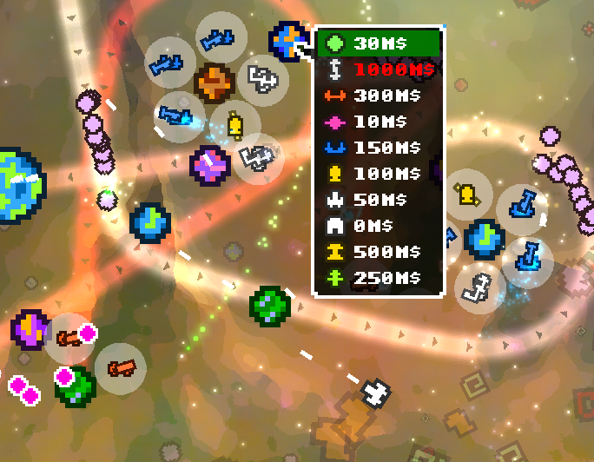

One player is controlling spaceships to do extra damage or collect minerals.

One player is controlling the manual turrets

One player is installing and upgrading turrets

Figure 6 : Example of dividing the task

*Commander* was designed as a single player game and LAN supports or other multiplayer game modes (ex: slayer, team slayer, capture the flag, etc.) are not feasible without changing a lot of the game logic. On the other hand, *Commander* already supports multiple input devices (ex: 1 mouse and 3 game controllers) which is half of the job required for the proposed game mode. The other half of the job is to modify the GUI behavior to supports multiple players.

Also, the Windows release of *Commander* will supports leaderboards for each level. These leaderboards will be hosted on ephemeregames.com.

# To do:

* Add supports for multiple opened menus and inputs in the GUI;
* Add player log in / log out in main menu;
* Design specific multiplayer levels (multiplayer world?);
* Change the help menu to include instructions for multiplayer;
* Add supports for multiple mouse inputs (optional);
* Test Xbox 360 integration.
* Create the leaderboards page.
* Add a component in the game to make an HTTP call to ephemeregames.com to submit the score at the end of a level.

1. Assets (Graphics & Audio)

*Commander* has colorful pixelated/retro graphics, retro sound effects and classical music that set it apart from other games. With the plan to add 40+ levels and 7+ worlds to the final product, what will make *Commander* even more attractive is:

* More assets of the current theme (planets, backgrounds, particle effects, ...);
* Story specific assets; for example, an alien-equivalent set;
* New graphic styles that are used sporadically (i.e. in some levels only).

# Story specific sets

As said in the *Worlds* section, there will be 5 environments and each of them requires new assets. These assets will have the same look and feel of the current theme.

# New Graphics Styles

Inspired by *Super Meat Boy* and *Fez*, *Commander* would benefit from a radical change of theme from time to time (i.e. in some levels only). *Commander* has supports for swappable asset packages and the work necessary for multiple themes is mostly a designer’s one.

**Realistic**

This theme use real space backgrounds, planets and asteroids[1] combined with more elaborated sound effects and electronic ambient music[2].

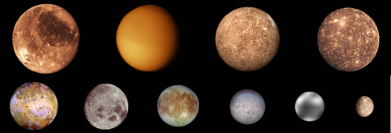

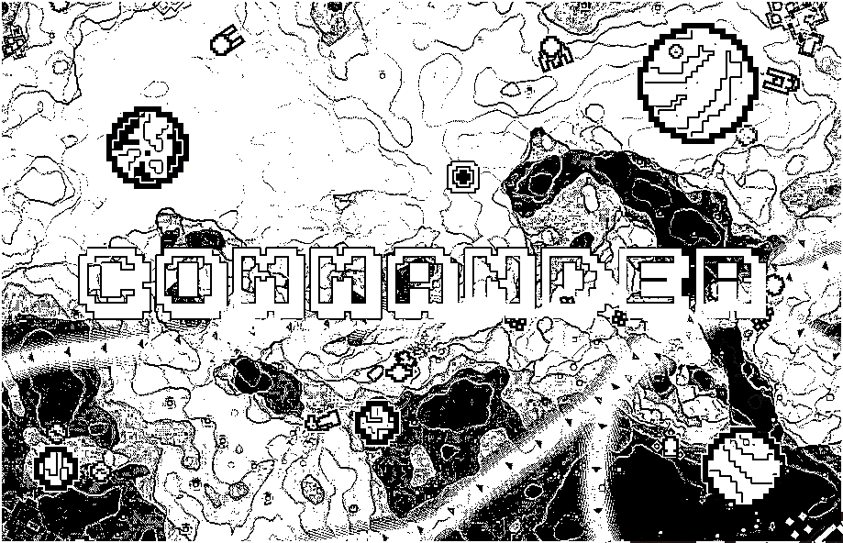**Cartoonish / Black & White**

This theme will make all the graphical assets looks like inked painted cartoons. This theme could be split in a cartoonish theme and a black & white theme. Note: the example below is not representative of what this theme could be.

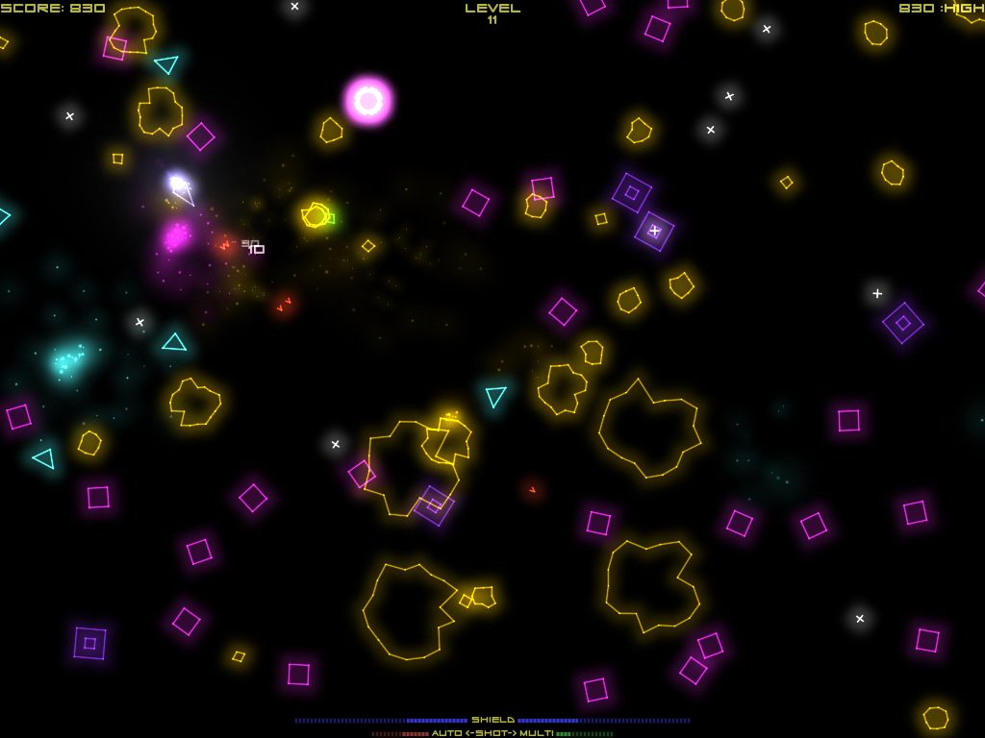

**Vectorial / Retro**

This theme will make all the graphical assets look like neo-retro vector graphics (i.e. glowing) on a dark background, which will make the particle effects stand up even more.

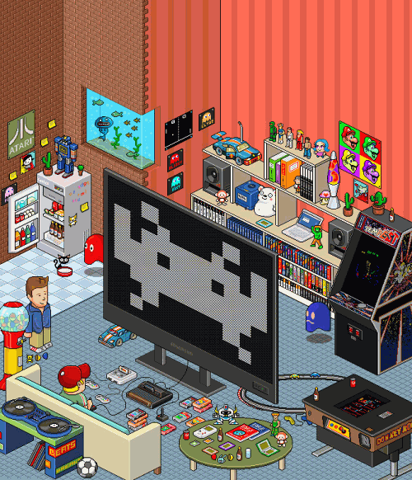

**Isometric**

This theme will make all the graphical assets have an isometric look. [Technical] With some tweaks, the current asteroid belt in each level could also have a 3D look with the asteroids growing bigger when approaching a central point on their elliptic path.

# To do:

* As stated in the *Worlds* section, produce new assets, which include: backgrounds, enemies, turrets, things to protect and turrets placeholders, animations, sound effects, particle effects and music.

1. Improvements

# More tips for beginners

The current menu has no indication that the player is actually in a menu. For some players, this is too much disorienting and indications (click here to begin, here is your cursor, etc.) must be added to clarify this fact.

# Bugs

* The preview of the path can be weird at times;
* The laser turret may continue firing at an enemy even if this enemy is out of range;
* A turret to buy is not selected when the player has now enough money to buy one.

# Remove the product key protection in the Windows release

The Windows release has a weak product key protection that is only causing trouble to customers. Thus, this protection will be removed in the final product.

# Test and pass XBLIG marketplace evil checklist

To be accepted on the XBLIG marketplace, the game must pass the game submission checklist and peer reviews. The final version will pass this checklist.

1. Images from NASA are royalty-free.
2. From the electronic group Conquistadors